The Ecology of Lyme Disease

What is Lyme disease?
Lyme disease begins when a tick bite injects Lyme disease bacteria into a person's blood. Early symptoms of Lyme disease usually include a bull's-eye skin rash, aches, fatigue and fever. If the infection is untreated, Lyme disease can cause damage to a person's joints, heart and/or brain.

Black-legged ticks and Lyme disease bacteria
Most cases of Lyme disease in the US result from the bite of a black-legged tick that has been infected with Lyme disease bacteria. Black-legged ticks are parasites which suck blood from mammals, birds and other hosts. A black-legged tick has three blood meals in its lifetime, one each as a larva, a nymph and an adult. Each blood meal lasts several days.
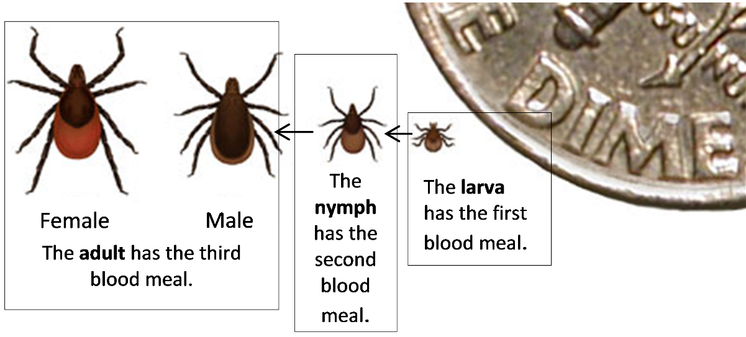
1a. When a black-legged tick has a meal, it not only sucks in blood – it also secretes saliva into the host. The tick's saliva contains chemicals that increase blood flow and inhibit blood clotting. Explain how these chemicals in the saliva are useful for the tick.

1b. Chemicals in tick saliva also inhibit pain and itching. Explain why this is useful for the tick. What might happen to the tick if the tick bite caused pain and itching during the long blood meal?

Lyme disease bacteria can survive and reproduce in ticks and in many of the mammal hosts that ticks feed on. Lyme disease bacteria are not passed directly from one tick to another or from one mammal to another. Instead, Lyme disease bacteria are transmitted back and forth between ticks and their mammal hosts:
Lyme disease bacteria in saliva
Infected black-legged tick Mammal host may become infected.

Lyme disease bacteria in blood meal
Infected mammal host Black-legged tick may become infected.

Black-legged ticks alternate between several days of feeding on a host and long periods of development in the damp layer of decaying leaves on the ground in forests. Ticks on the ground are in danger of drying out and dying. This is one important reason why ticks are more often found in forests and less often found in sunnier, dryer areas such as lawns.

2. Black-legged ticks generally have a two-year life cycle. This table shows when the three blood meals occur during this two-year life cycle in the northeastern US. Complete the sentences to illustrate how Lyme disease bacteria alternate between living in ticks and living in the mammal hosts of ticks.

Year | Season | Tick Feeding
1 | Late summer and early fall | Tick larva feeds on a white-footed mouse, shrew or other small mammal host.  If the mammal host is infected with Lyme disease bacteria, the blood meal infects the ______________________.
2 | Late spring and early summer | Tick nymph feeds on a mammal host (e.g. a white-footed mouse, shrew or person). If the nymph is infected with Lyme disease bacteria, its saliva can infect the ___________________________.
2 | Fall, early winter or spring | Tick adult feeds on a white-tailed deer, raccoon, opossum or other large or medium-size mammal.

3. This figure illustrates the two-year lifecycle of black-legged ticks. To make the figure more complete, use the information from the above table to add the following information for each of the feedings:
– the seasons when this feeding occurs
– two examples of mammals that can be a host for this feeding.
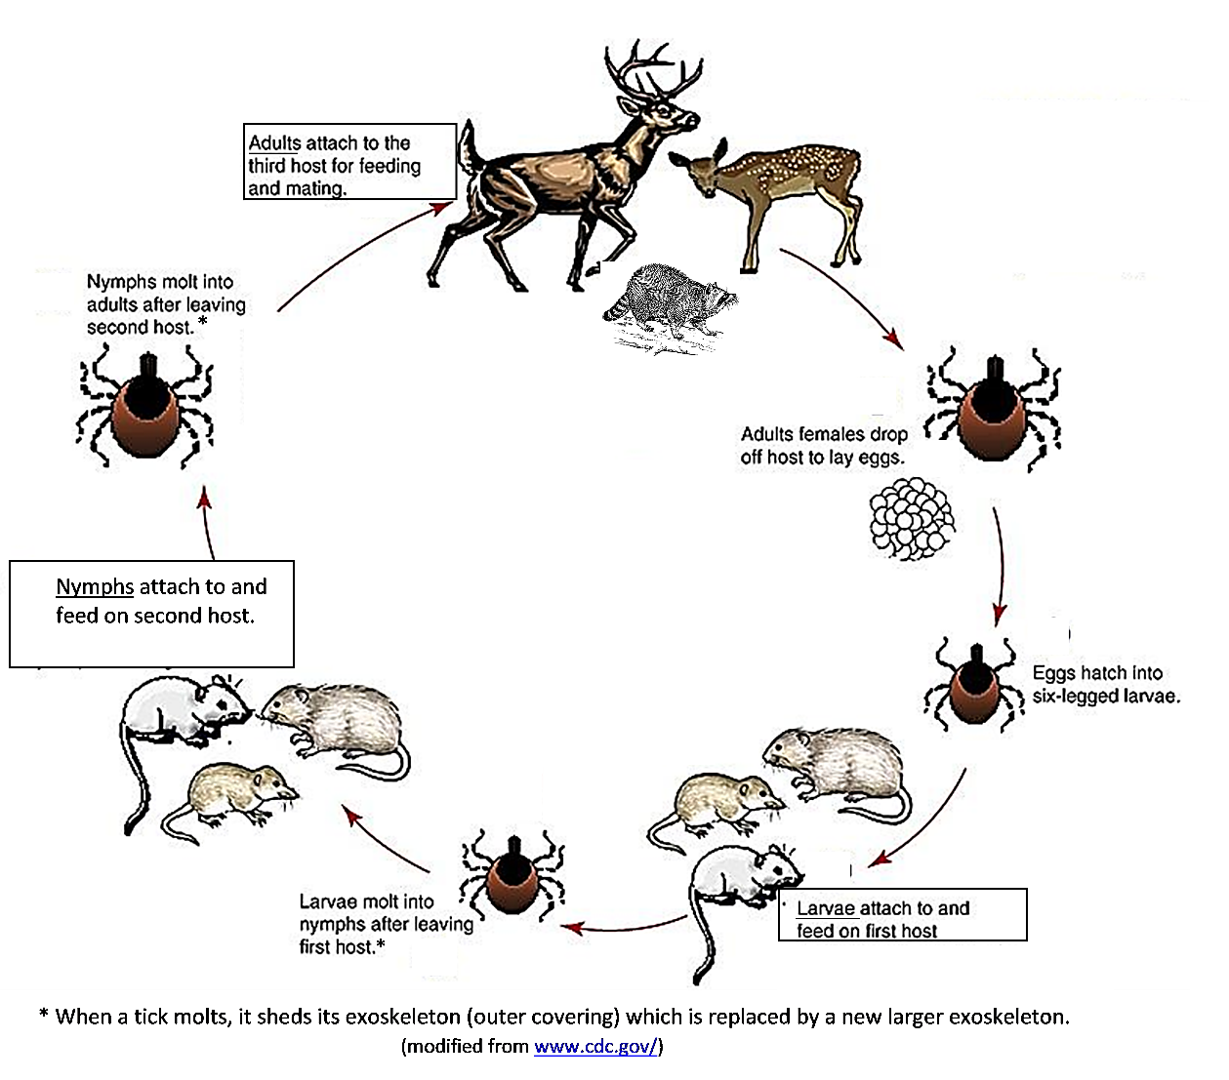

Tick eggs are not infected with Lyme disease bacteria, even if their mother was infected. Thus, tick larvae are not infected before they have a blood meal. If a tick larva feeds on an infected host, the larva will become infected with Lyme disease bacteria, and the infected larva will develop into an infected nymph and adult.

4. The first graph shows seasonal variation in feeding for tick larvae ( ), nymphs ( ), and adults ( ). The second graph shows seasonal variation in when Lyme disease cases begin. Based on this evidence, are most cases of Lyme disease caused by the bite of an infected tick  larva ____ nymph____or adult___?  Explain your reasoning. | 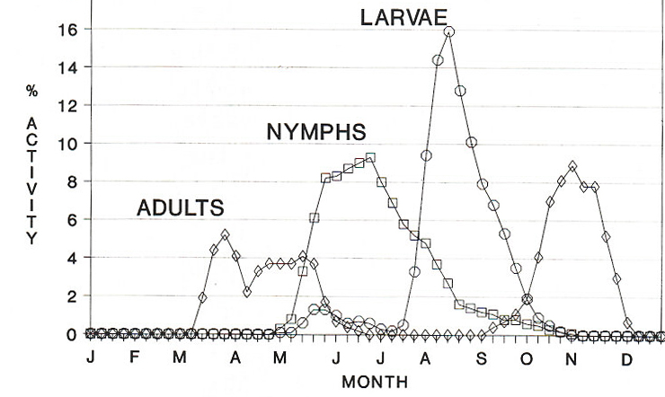  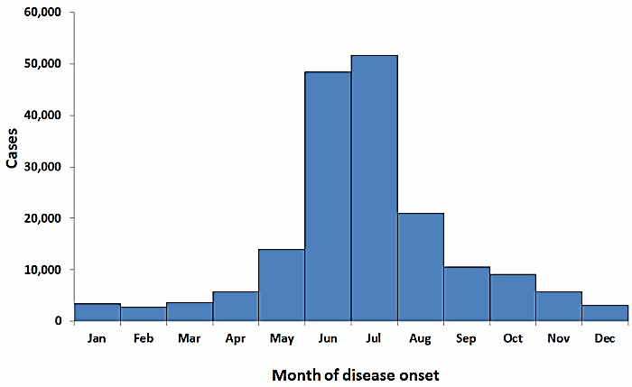  % Activity = % of feeding episodes for each developmental stage that occurred in  each week of the year. Month of disease onset for confirmed Lyme disease cases,  US, 2001-10 (http://www.cdc.gov/lyme/images/statstables/month_700pxW.gif)

5a. Lyme disease bacteria reproduce by dividing in two. These bacteria can reproduce inside black-legged ticks and inside white-footed mice or other mammal hosts. However, reproduction inside a single animal is not enough to ensure the survival of Lyme disease bacteria. Suppose that the Lyme disease bacteria in a tick could reproduce inside the tick, but could not transfer from the tick to a mammal host. What will happen to this population of Lyme disease bacteria when the tick dies?

5b. When a tick sucks in a blood meal that contains Lyme disease bacteria, at first these bacteria live in the tick’s gut where the bacteria get nutrition from the blood meal. When the tick begins its next blood meal, the Lyme disease bacteria move from the tick's gut to its salivary glands. Why is this ability to move to the salivary glands a needed adaptation for Lyme disease bacteria? What would happen to any Lyme disease bacteria that were unable to move from the tick's gut to its salivary glands?

Forest Ecosystems, Lyme Disease Trends and Prevention

6. Explain why ticks are more common in forests than in open fields or lawns. (Hint: See the top of page 2.)

7. During the twentieth century the amount of forest increased substantially in the northeastern US. A major reason for this trend was that many farms were abandoned and forests gradually developed on the abandoned farmland. Explain how, over many decades, natural processes can result in the growth of forests in abandoned farm fields. (Hint: Recall what you have learned about succession.)

In the northeastern US in the last half-century, increased forest habitat has contributed to the spread of black-legged ticks, and the spread of black-legged ticks has contributed to increased rates of Lyme disease. Another reason for increased rates of Lyme disease has been increased exposure of humans to black-legged ticks, as more people have moved from cities to the suburbs. People who live in a home next to a wooded area can be exposed to ticks in the wooded area and to ticks that spread to the home’s lawn and plantings.

8. How have changes in human behavior contributed to increased rates of Lyme disease in the last half-century?

9. This figure shows a small part of the food web in a forest in the northeastern US. Each arrow shows a major source of nutrition for the type of organism the arrow points to. Use asterisks to indicate three types of organisms that provide nutrition for Lyme disease bacteria.
- For the top five boxes, label the organisms as carnivores, herbivores, omnivores, external parasites, or internal parasites. (A carnivore predator kills and consumes all or most of its prey. In contrast, a parasite consumes relatively small amounts of nutrients from the host. Internal parasites live inside the host, whereas external parasites attach to the outside of the host.)
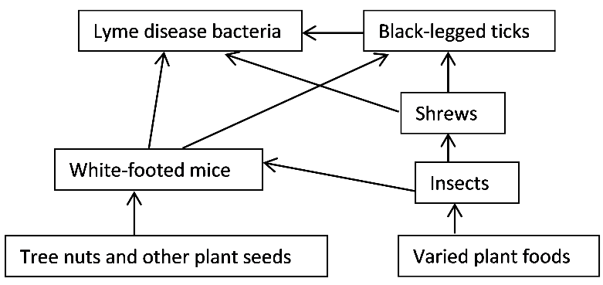

You have seen that human risk of Lyme disease depends on interactions between multiple organisms in a forest ecosystem. Researchers have tested whether Lyme disease risk can be reduced by making changes in this ecosystem. Two examples of this type of ecological approach to preventing Lyme disease are illustrated in this flowchart.
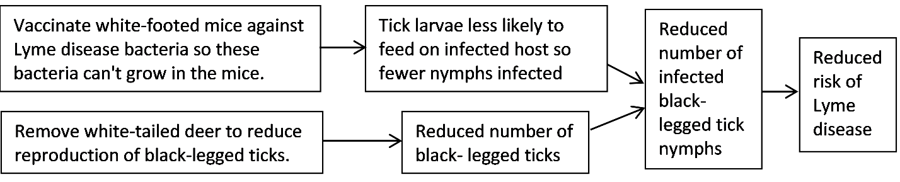
10a. Explain how vaccinating white-footed mice against Lyme disease bacteria could reduce the risk of human Lyme disease.

10b. Researchers have found that, as expected, vaccination of white-footed mice did reduce the percent of black-legged tick nymphs that were infected with Lyme disease bacteria. However, even after the white-footed mice were vaccinated, some tick nymphs became infected. Explain how some tick nymphs could become infected with Lyme disease bacteria, even though white-footed mice had been vaccinated. (Hint: See page 2.)

11. Even in areas with no white-tailed deer, there are some black-legged ticks and some cases of Lyme disease. How can black-legged ticks reproduce, even when there are no white-tailed deer?

12. Susan lives in a suburban home in the Northeast and likes to walk her dog in the neighboring wooded area. Based on what you have learned thus far and the information in the box on the right, suggest several ways that Susan can reduce her risk of Lyme disease. Be as specific as you can. | A black-legged tick that is seeking a blood meal leaves the moist layer of decaying leaves and climbs up a blade of grass or other plant. When the tick detects a potential host it waves its front legs around and tries to attach to the host. Once on the host, the tick crawls to a suitable spot and bites and attaches. The tick feeds for several days; few Lyme disease bacteria are secreted in the saliva during the first day or two.

By Dr. Ingrid Waldron, Dept. Biology, Univ. Pennsylvania, © 2015. This Student Handout and the related Teacher Notes with background information and instructional suggestions are available at http://serendipstudio.org/exchange/bioactivities/LymeDisease

